REMOTE WORK PROGRAM
EXPECTATIONS AND BEST PRACTICES FOR WORKING REMOTELY

Our team is are our #1 priority! Our culture embraces agility, efficiency,
and a practical approach to how, when, and where we work.

SAMPLE PROGRAM
MARCH 2020

Prepared by ESM Solutions, Inc. This program is a merely a guideline and does not guarantee compliance with all applicable Federal, State or Local OSHA standards. It is solely the responsibility of the Employer to make sure that their Risk Management and/or Safety Program is compliant with all applicable laws.
© 2020, All Rights Reserved

Table of Contents
OVERVIEW 3
IS WORKING AT HOME APPROPRIATE FOR ME? 4
EMPLOYEE RESPONSIBILITIES 5
PROFESSIONALISM 5
COMMUNICATION 6
MAINTAINING BUSINESS PRACTICES AND PERFORMANCE 7
EXPECTATIONS FOR SUPERVISORS WITH EMPLOYEES WORKING REMOTELY 8
BEING EFFECTIVE FROM HOME 9
TECHNOLOGY INFRASTRUCTURE AND REQUIREMENTS 12

OVERVIEW
The health and safety of our team is our #1 priority. Our [Company] culture embraces agility, efficiency, and a practical approach to how, when, and where we work.

We consider the flexibility provided by multiple types of work environments an important tool supported by our regular investment in technology and communications platforms.

This module provides answers to many of the frequently asked questions about our “remote work” policy and helps ensure our mutual success.

Because of the collaborative nature of our work, we invest in effective and comfortable office environments. We also understand that our culture reinforces collaboration, hard work, and an enjoyable atmosphere that is supported by these environments.

When appropriate and necessary, [Company] supports remote work as an essential alternative to being physically located at a Company office. These circumstances may include business, geographic, personal, and other reasons where our approach to meeting our client’s needs, supporting our team, and attracting and retaining the best professionals is achieved with alternative work locations. Other instances where remote work may be appropriate include major weather events, local, state, or national emergencies; or local office constraints. Remote work includes work from home (WFH).

It is [Company]’s general policy to provide the flexibility to accommodate remote work to assist with:
- The health and well-being of an employee or their family
- The needs of co-workers
- [Company] business operations
- Our customer’s needs

Our individual work-style preferences influence how, where, and when we work most effectively. This module provides the overall decision-making framework for [Company] employees and supervisors when considering the appropriateness of remote work options.

[Company] has a dedicated and talented team, and we trust our team to make sound decisions and do the right things. This trust applies to our team’s ability to meet certain expectations while working remotely.

When an employee is working remotely, they must continue to perform at the same high level that is expected while working in any [Company] office. We recognize this may require extra discipline and focus. Each employee must be committed to [Company]’s overall vision, their teams, and the specific requirements and responsibilities of their position.

Do you think you have a need to work remotely, and can you continue to perform at a high level?

To help you think through this, we have included a few important questions below. Discuss your answers with your supervisor using this guide to help you understand expectations and requirements.

IS WORKING AT HOME APPROPRIATE FOR ME?
ANSWER THE FOLLOWING QUESTIONS TO HELP YOU DECIDE:

- Can I perform my assigned duties from my home or other remote location?

YES NO

Explain

- Will my remote office environment allow me to be as efficient and effective as I am in my [Company] office?

YES NO

Explain

- Will my co-workers be able to rely on me, communicate with me, and collaborate with me in a manner consistent with working from my [Company] office?

YES NO

Explain

- With appropriate support from [Company]’s IT Department, do I have the IT infrastructure necessary to work efficiently and effectively from my home?

YES NO

Explain

- Will I meet [Company]’s expectations and my responsibilities while working from my home?

YES NO

If Yes Explain

Discuss your answers with your supervisor.
Do they agree with you?

EMPLOYEE RESPONSIBILITIES
If approved to work from your home, remember, this approval comes with the unequivocal responsibility that you will do the following:
- Be a professional and represent the [Company] brand
- Perform your work assignments and duties just as you would if you were working in an [Company] office in front of your peers and supervisor
- Communicate and stay in contact with your supervisor, team members, and clients
- Stay focused on your performance and that of your teams and projects and the quality of your work
- Take care of your clients
- Take care of yourself

PROFESSIONALISM

Everyday [Company] professionals deliver high-quality and innovative services to our clients, making our customers and communities safer and better. We have confidence that [Company] employees will maintain the same level of professionalism we expect wherever they represent our firm.

We anticipate you will:
    - Be responsive to your supervisor, co-workers, and clients
    - Ensure that all work is checked and meets [Company] quality requirements
    - Over-communicate…never assume that your team knows your work schedule, or what you are thinking or doing. Share your thoughts and concerns about your work or the work of others early, often, and clearly. Respond to emails and phone calls timely
    - Create a dedicated, professional and organized environment that promotes effective work from home and represents the [Company] brand with clients
    - Be prepared to address signing, oversight, review, and other regulatory issues
    - Continue to learn
    - Use the “Best Practices” guide provided below

COMMUNICATION
Effective communication is an [Company] Core Value. With every communication, we expect [Company] employees to be open, respectful, and honest. This does not change when an employee is working remotely. In fact, it is incumbent on the employee to increase the level of communication and:
- Err on the side of over-communicating with your team. Conduct at least once daily check-ins with your team members
- Be responsive. Answer all emails, phone calls and instant messages from co-workers and clients as soon as possible, and always on the same day received. Answer all emails and calls from your supervisor within one-hour
- Keep your calendar detailed and up to date. If you are taking lunch or otherwise stepping away from your at-home workstation, note it on your calendar. If you are working on the weekend, note it on your calendar. Not being in the office increases the necessity that others are kept aware of your availability/non-availability
- Use real-time tools. Use tools like Zoom and Microsoft Teams to replicate in-person interactions and conversations with your team members
- Provide contact information. Make sure your supervisor, co-workers, and clients know how to contact you at home (e.g., provide your cell phone number and forward calls from your office phone to your cell)

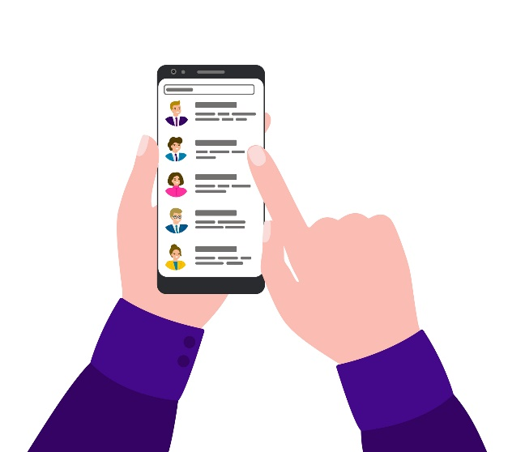
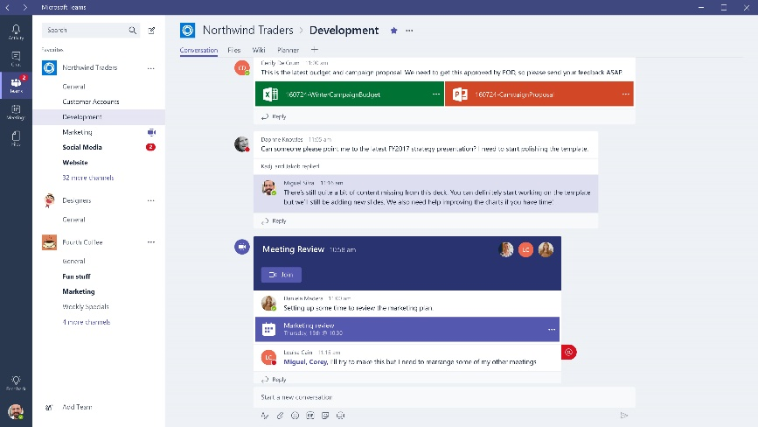

MAINTAINING BUSINESS PRACTICES AND PERFORMANCE
It is essential that working from home does not diminish the timely performance and quality of our work, and the financial health of [Company]. Those employees approved for remote work status have the same level of responsibility for meeting [Company]’s business objectives as if working from an [Company] office.
The following list reflects the basic business performance requirements that must be met while working remotely. Your supervisor may add additional requirements.
- Billable Hours. Your minimum billable hours per week do not change if you are approved for remote work status. Billable hours are those invoiced that result in billable net revenue. Such hours may be completed during any of the five days of the workweek consistent with your supervisor’s approval and the needs of projects, teams, and clients. Billable hours are not the same as non-billable hours charged to a project on your timecard. If you do not know your minimum billable hours, please discuss with your supervisor
- Utilization. Meeting utilization targets is an important part of meeting [Company]’s business objectives. Your utilization target does not change if you are approved for remote work status. If you do not know your utilization target, please discuss with your supervisor
- Project Performance. All in-office requirements for project performance remain in effect. Employees working remotely, especially project managers, must ensure that contract project multipliers are achieved, even if extra work is required.
- Timecards. Pursuant to our current policy, timecards must be completed at least daily and updated in our tracking system.

Meeting the above business performance metrics is vital to a successful remote work program. Talk to your supervisor if further clarification is required.

EXPECTATIONS FOR SUPERVISORS WITH EMPLOYEES WORKING REMOTELY
Supervisors shall apply this guidance before approving a request for remote work. We understand that in limited situations, legitimate exceptions to the policy may be warranted. Such limited exceptions must be approved by the appropriate division leader.
When considering remote work for [Company] offices with employees from more than one department, each applicable supervisor should formally coordinate how to apply this [Company] Remote Work Guide in the most consistent manner practicable. It is understood that the specific work environment and duties may result in different approaches between divisions (e.g., field versus office employees).
RESPONSIBILITIES
As the leader of an [Company] department, you have the responsibility to:
- Ensure that employees are meeting the professionalism and business expectations outlined above
- Ensure that employees and team members are communicating effectively
- Ensure that you and your teams are meeting client contract and QA/QC requirements
- Ensure that your teams are meeting scope of work and schedule requirements
- Check in on your employees regularly via video
- Be available to your employees

COMMUNICATION
An essential attribute of all successful managers and leaders is effective communication skills. [Company] department leaders must focus on their communication efforts when employees and teams work remotely.
The minimum actions required to ensure effective communication with employees working remotely include:
- Over-communicating with your employees and teams. Conduct daily video check-ins with the team. Keep your calendar detailed and up to date, so employees know when they can reach you. Be responsive to your team, responding to emails and calls as soon as possible, and always on the same day
- See their faces. Require employees to use the video feature on their computers (e.g., Zoom video, Microsoft Teams), or Face Time/similar applications on cell phones
MONITORING AND REPORTING
Department and division leaders must monitor the efficiency and quality of deliverables resulting from remote work activities. Specifically, you should evaluate the following for each employee working from home:
- Ensure billable workload (daily)
- Billable hours (minimum of weekly)
- Utilization (weekly)
- Timesheet postings (daily checks)
- Project performance (bi-weekly)
- QA/QC (random weekly checks)
- Client satisfaction survey scores

BEING EFFECTIVE FROM HOME
We are confident that [Company] employees will be effective when working remotely. Working remotely, however, can be a challenge, especially if you add the significant stressors and potential infrastructure interruptions that may accompany remote environments. To help, we have provided the following “Best Practices” on how to optimize your productivity and mental well-being.
1

DEPENDENT CARE CONCERNS
Everyone recognizes that work from home is not a substitute for childcare or eldercare. Caregiving is its own job. It typically is not compatible with remote work. We know it is not possible to devote your full attention to your professional duties when you are committed to taking care of others.

You and your supervisor will need to set realistic expectations if caring for others affects your ability to focus on work while at home. We understand that situations like this may be more likely to require a combination of part-time work, shift work, and the use of PTO.
2

REMOTE WORK BASICS
- Establish Goals. Develop daily lists of goals and assignments (e.g., use the Microsoft Office OneNote application). At the end of each day, go over the list and note your accomplishments. Most accomplishments should be reflected on the required daily update to your timesheet.
- Plan in advance. List all tasks and upcoming work that you may need to perform remotely. It’s helpful to start the list in advance, so you can arrange for all the resources you’ll need at home.
- Assess your telecommunications services. (e.g., internet speed) at home, and any computer hardware or software you may need. Be sure that you have all the information you need at home regarding remotely logging-in to systems. Make sure you have good cell coverage and that your office phone is forwarded to your cell if needed.
- Have a backup plan. Remember that during some events, regular telecommunications services and power may be limited or interrupted, so be certain that you and your supervisor agree on multiple communication channels that allow you to remain well-informed of changes regarding your work teams or supervisor’s plans.
- Communicate with your supervisor. When working remotely, you’ll need to keep your supervisor informed about your progress and any difficulties you encounter.
- Be accessible. Stay in touch with your clients, co-workers, and teams. Have a system where you are easily reached. Use video when talking to others
(e.g., Zoom, Teams).

3
MAINTAIN REGULAR HOURS
Set a schedule and stick to it... most of the time. Wake at the same time and prepare yourself for work just as you would if going to an [Company] office.
4

CREATE A MORNING ROUTINE
Deciding you’ll sit down at your desk and start work at a certain time is one thing. Creating a routine that guides you into the chair is another. Get your coffee, exercise, or walk your dog. Just try to do what you would normally do before you go to your [Company] office, including getting dressed like you are going to the office. The way you dress has been proven to affect you psychologically.

5

SET GROUND RULES WITH PEOPLE IN YOUR SPACE
Avoid distractions by setting ground rules with other people in your home or who share your remote workspace. If you have children at home while you’re working, establish clear rules about what they can and cannot do while you are working.

6

SCHEDULE BREAKS. TAKE THEM IN THEIR ENTIRETY!
A break is good for your eyes, productivity, and sanity. Don’t short- change yourself during breaks, especially your lunch hour. Whenever possible and safe to do so, leave the inside of your home for a short period. Leaving the house on occasion provides a change of scenery, which can help boost creativity and productivity. Consider taking virtual breaks simultaneously with your team to discuss things other than work. When you do leave, note it on your calendar.

7

ASK FOR WHAT YOU NEED
Work with your supervisor and IT Department to make sure you have what you need to effectively do your job.

8

KEEP A DEDICATED OFFICE SPACE
If you do not have a home office, set aside a place for work that does not have another daily purpose. If it’s a room with a door, even better; ideally, it’s a desk instead of a kitchen table, bed, or living room couch. Make sure that the space is suitable for video and audio with a proper background and acoustics. Remember, others can see you, and they need to hear you.

9

BE HONEST WITH YOURSELF
Remote working may not be a viable option for every employee. If you find that working from home is negatively impacting your productivity or making you feel disconnected from your team and your work, speak to your supervisor.

100

YOU ARE NOT ON AN ISLAND
Even when you are at home, you are still a part of the [Company] team and family. Do not feel alone or isolated – you have your teammates that count on you. And you can count on them.

TECHNOLOGY INFRASTRUCTURE AND REQUIREMENTS

[Company] invests continuously in technology and tools and has a talented IT team to work with employees and supervisors to support remote work initiatives.
Each employee that is approved for work from home should work with IT and discuss hardware and software needs and the specifics of the employee’s home technology, including internet speeds.
If you are taking office equipment (other than your laptop) home with you, such as monitors, docking stations, tablets, speakers, etc., please notify IT in advance. All [Company] equipment should be plugged into surge suppression devices, and desktop computers should use battery backup devices as well.
A few basic technology and IT tips include:
1
IT SECURITY
Exercise the same level of awareness and vigilance for emails or other communications from unknown or suspicious sources, including potential phishing, ransomware, or other malicious files. Contact the IT Department immediately if you have received any such email or communication.
2

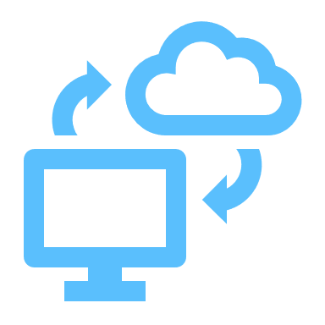
VPN AND REMOTE ACCESS
VPN access for [Company] computers: If you have a company supplied laptop or you are taking home an office desktop, engage IT for support with the requirements for remote access.
3

TELEPHONE CALL FORWARDING
When working from home, your office line should be forwarded to your cell number or computer as applicable (e.g., TalkDesk). For those without an [Company] cellphone, [Company] will reimburse for reasonable and appropriate work-related charges that support your need to work from home.
4

VIDEO CONFERENCING
When working from home, you should anticipate more video conference calls to facilitate communication with your team, supervisor, and clients. All laptops have cameras. Video conferencing using your camera is the default means of communicating with your supervisor or co-workers. This ensures you stay connected, and issues are understood. If you are bringing a desktop
computer home, coordinate with IT to be certain you have a camera installed.
5
IT TRAINING AND TECHNICAL HELP
Training on how to use Zoom and Teams is available in our Public Drive.

The information provided in this document is of a general nature, based on certain assumptions, and cannot be regarded as advice that would be applicable to all businesses. Readers seeking resolution of specific safety issues or business concerns regarding this topic should consult a professional safety consultant. We do not warrant that the implementation of any view or recommendation contained herein will result in the elimination of any unsafe conditions at your business locations or with respect to your business operations. We assume no responsibility for the control or correction of hazards, and the views and recommendations contained herein shall not constitute our undertaking, on your behalf or for the benefit of others, to determine or warrant that your business locations or business operations are safe or healthful, or are in compliance with any law, rule or regulation.

