SAFETY  TIP OF THE MONTH | 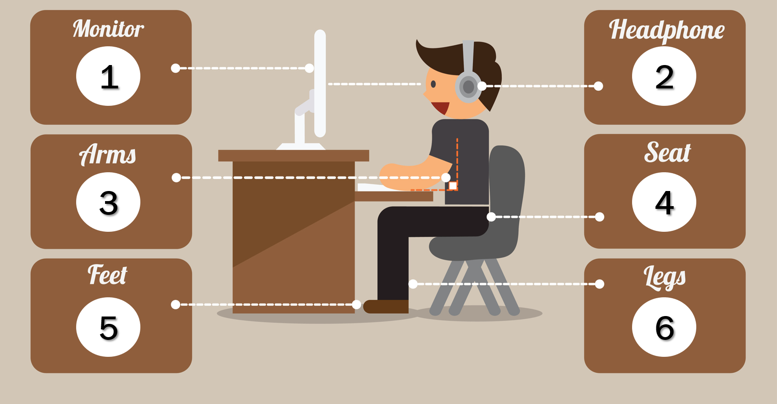  4. Seat, Chair  - Chair should be adjusted to your height  - Seatpan is appropriate width (1 inch on either side)  - Seatpan adjusted to correct depth (not to short/long)  - Seatpan has a front rounded edge  - Backrest is adjusted to your height and providing support  - Are you comfortable?  5. Feet  - Feet flat on the floor or on a footrest  - If standing, consider anti-fatigue mat  - Recommend alternating between sitting and standing to increase energy levels  6. Legs  - Should be slightly tilted downward  - Make sure there is clearance for your knees  - Shoulders are relaxed and not in a shrugged position  - Ensure there are no pinch-points in wrists or elbows  - Consider ergonomic / split keyboard if necessary  - Wrist cushions provide support for mouse and keyboard  General Best Practices  - Keep frequently used items within your primary work zone (within reach)  - Minimize clutter on top and below your desk  - Take frequent micro-breaks to increase circulation, energy levels and to promote stretching  - Be cogniscnet of sunlight from windows and potential glare throughout the day  - Consider various workstations that can be adjusted for both sitting and standing work. This is especially important for highly sedentary work or where work requires sitting or standing positions for long periods  - Conduct frequent exercises (office yoga) to minimize strain and static positions
Workstation Ergonomics
In order to reduce fatigue and strain on the neck, shoulders, back and legs it is important to setup your workstation ergonomically. While there is not one correct way to sit at a workstation, seating should support postures that can be changed frequently within a comfortable range throughout the day. The following are a few tips to propertly setting up your workstation.
- Monitor:
- Clear and easy to see
- The top of the monitor screen is at eye level
- Arms length away (18 – 28 inches from your eyes)
- Without glare
- With dual monitors, position yoru torso in the middle of where they converge
- Laptop users take frequent microbreaks and complete head and lumbar expercises

- Headphone/Headset:
- Wired or wireless (recommend Jabra)
- Prevent ackward cradeling
- Remember to always use!
- Arms, Armrests, Keyboard, Mouse
- Proper height (90 degree elbows)
- Arms should rest comfortably on armrests
- Shoulders are relaxed and not in a shrugged position
- Ensure there are no pinch-points in wrists or elbows
- Consider ergonomic / split keyboard if necessary
- Wrist cushions provide support for mouse and keyboard
Training Attendance Form

Company Name:

Date / Time:

Instructor:
Training: | Workstation Ergonomics
Training  Objectives: | - Review the 6 workstation ergonomic tips  - Review the general best practices for maintaining your workstation  - Discuss office and home workstation exposures and strategies

Print Name | Signature

